What is graph?

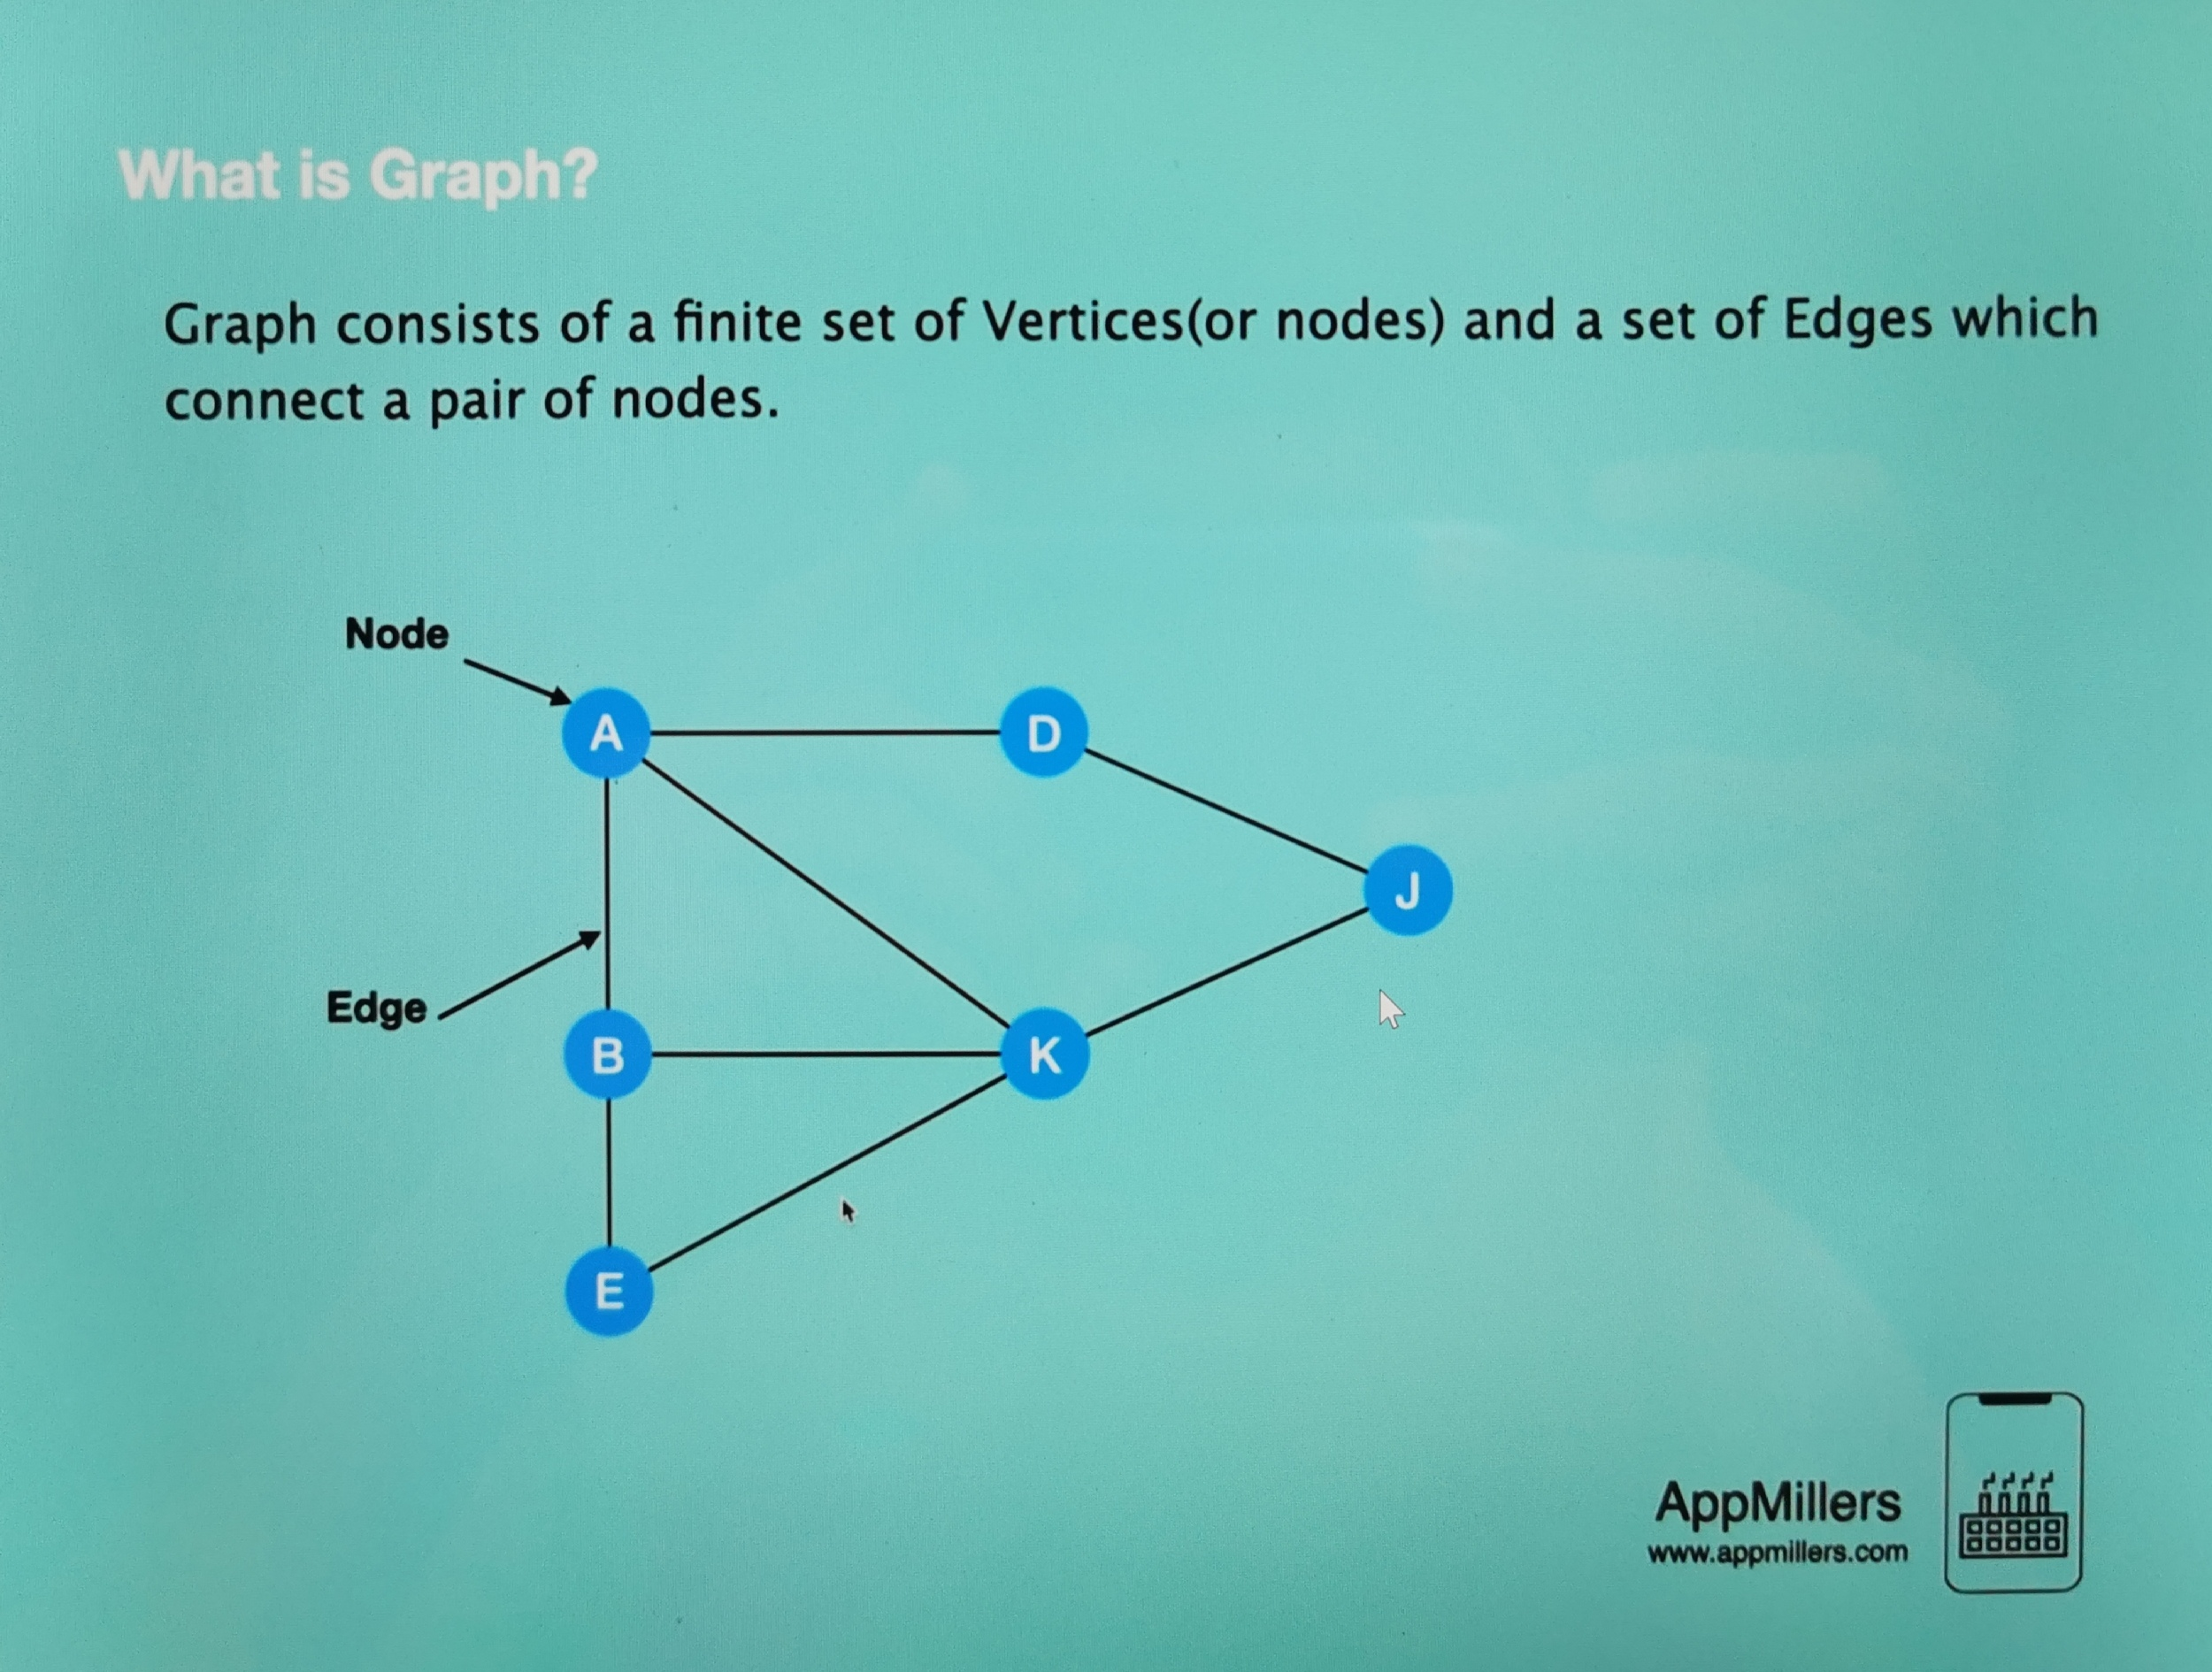

Graph terminology:

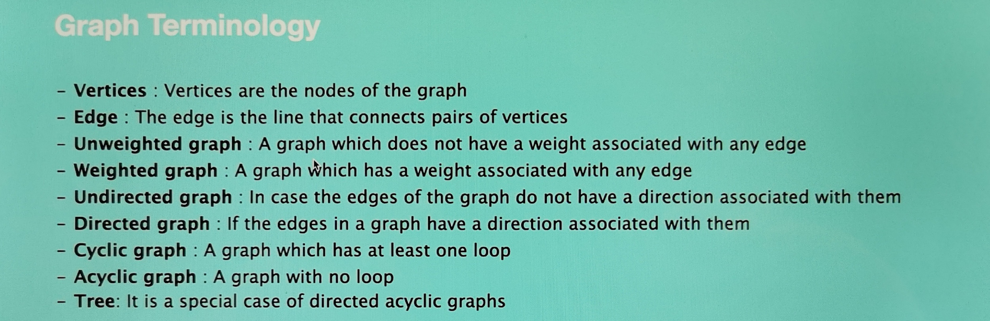Watch this if you don’t understand: [The Complete Data Structures and Algorithms Course in Python | Udemy](https://www.udemy.com/course/data-structures-and-algorithms-bootcamp-in-python/learn/lecture/21975826#overview)

6 types of graphs:

1. Unweighted – undirected
2. Unweighted – directed
3. Positive – weighted – undirected
4. Positive – weighted – directed
5. Negative – weighted – undirected
6. Negative – weighted – directed

For more info: [The Complete Data Structures and Algorithms Course in Python | Udemy](https://www.udemy.com/course/data-structures-and-algorithms-bootcamp-in-python/learn/lecture/21975838#overview)